Anstey Surgery Practice Catchment Area Boundary set by NHS England
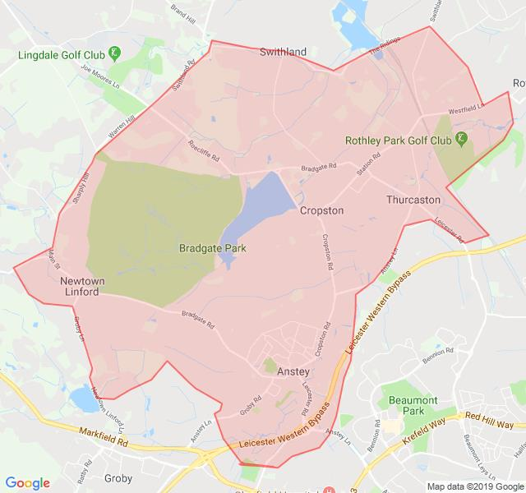
Catchment Area:
Anstey
Cropston
Newtown Linford
Swithland
Rothley (Swithland and Westfield Lane only)
Thurcaston

